**FLIGHT MANAGEMENT SYSTEM**

**Team Members:**

1.Snigdha Tiwari

2.P Manasa Devi

3.K Supritha

4. Sushmanth

**Abstract:**

The Flight Management System is a Java-based booking solution for flight tickets. It consolidates data provided by different airline carriers and hence provides the user details and rates in real-time. Travellers may want to make changes in their bookings. The application allows them to book, cancel, view and update their bookings with ease. Other than this, it eases the management of bookings too. All the bookings, flights, schedules and routes can be viewed, added and modified on a single application by the administrator.

There are two categories of people who would access the system: customer and administrator. Each of these would have some exclusive privileges.

**1. The customer can:**

a. Create his user account.

b. Login into the application.

c. Check for available flights.

d. Make a booking.

e. View the bookings made.

f. Cancel or modify a booking.

**2. The administrator can:**

a. Login into the application.

b. Add flight, schedule and route details.

c. View the flight, schedule and route details.

d. Cancel or modify the flight, schedule and route details.

**Class Diagram:**

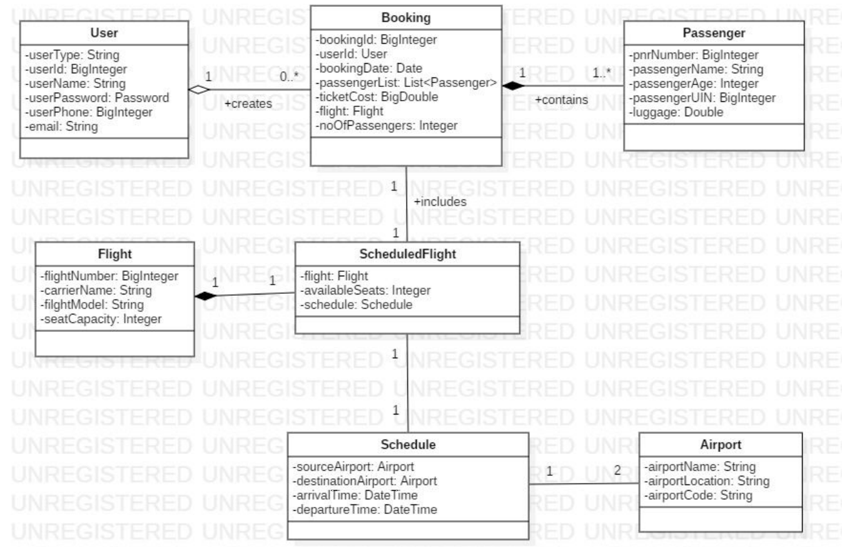

**Sequence Diagram for User:**

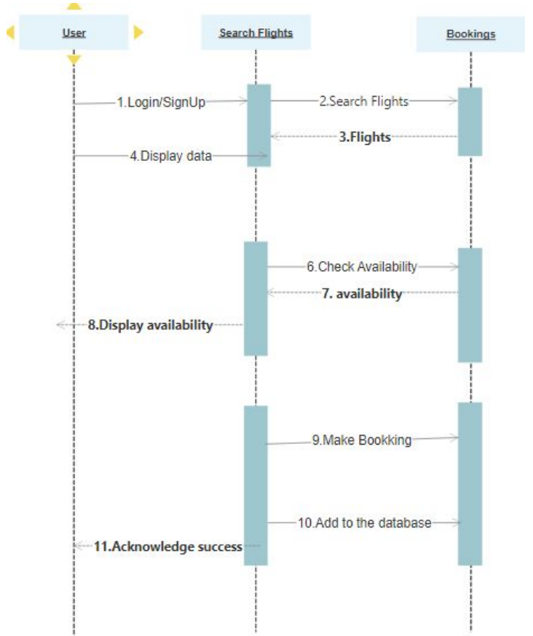

**Sequence Diagram for Admin:**

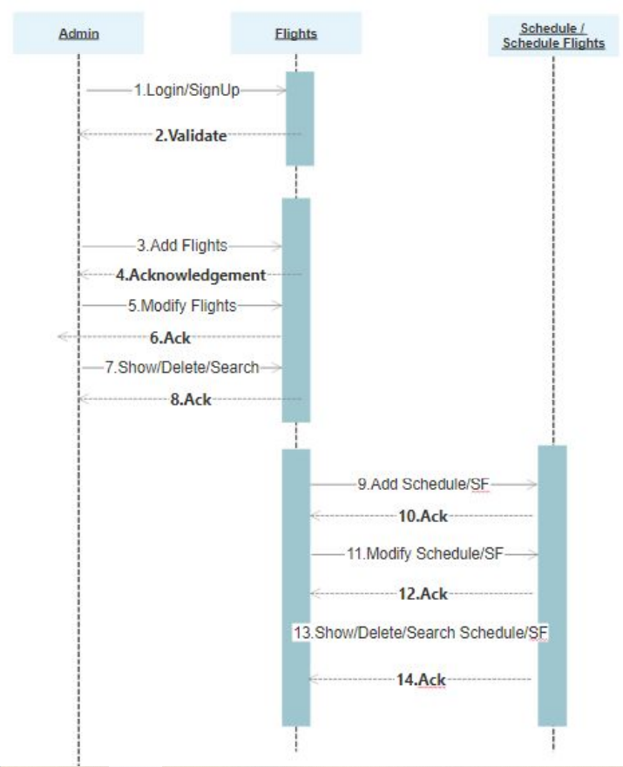

**Activity Diagram for Admin:**

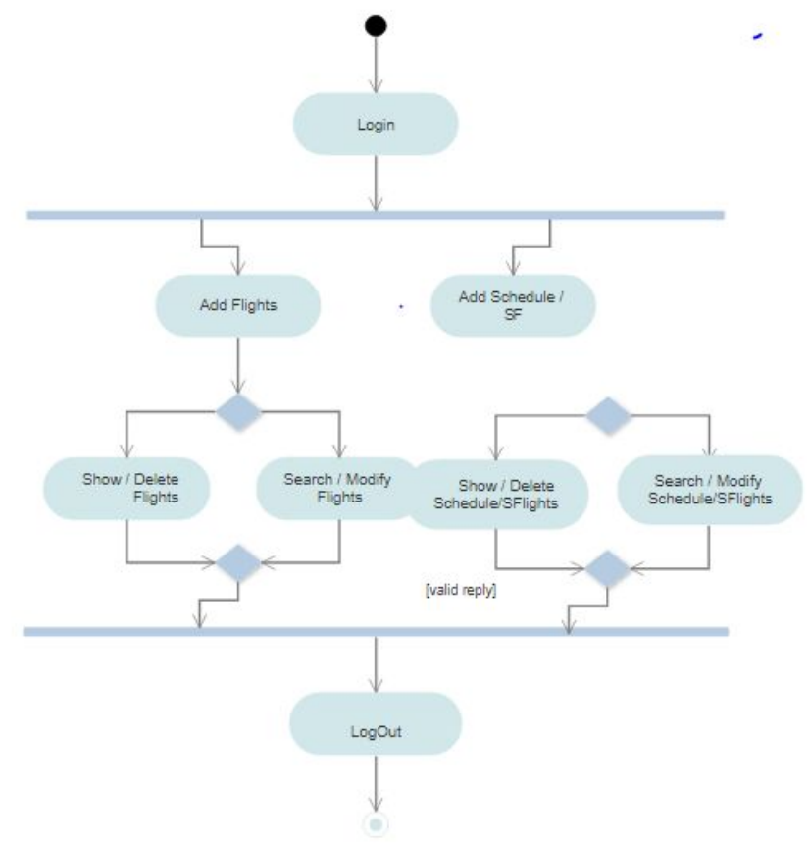

**Activity Diagram for User:**

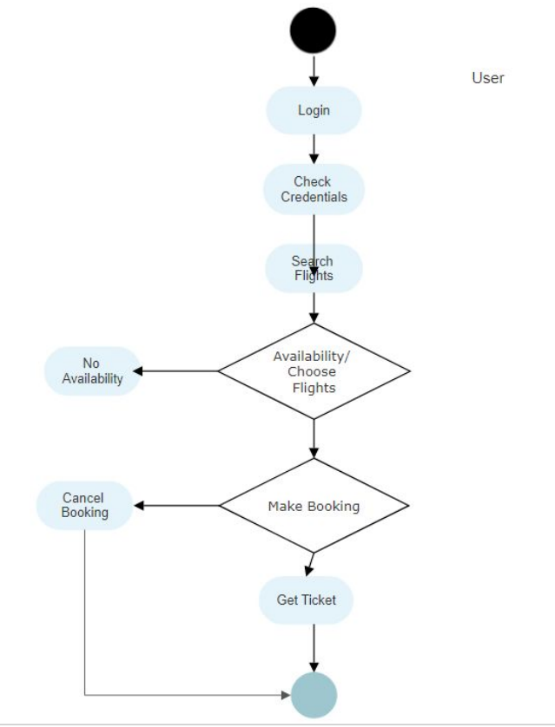

**Flow Chart:**

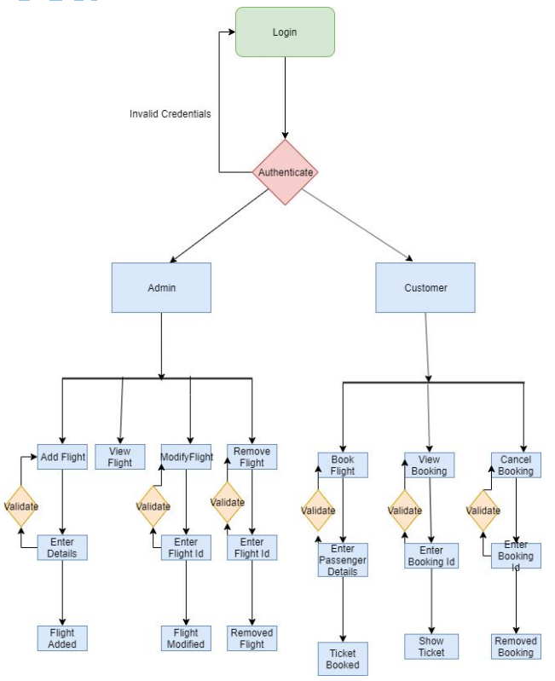

**Use Case Diagram:**

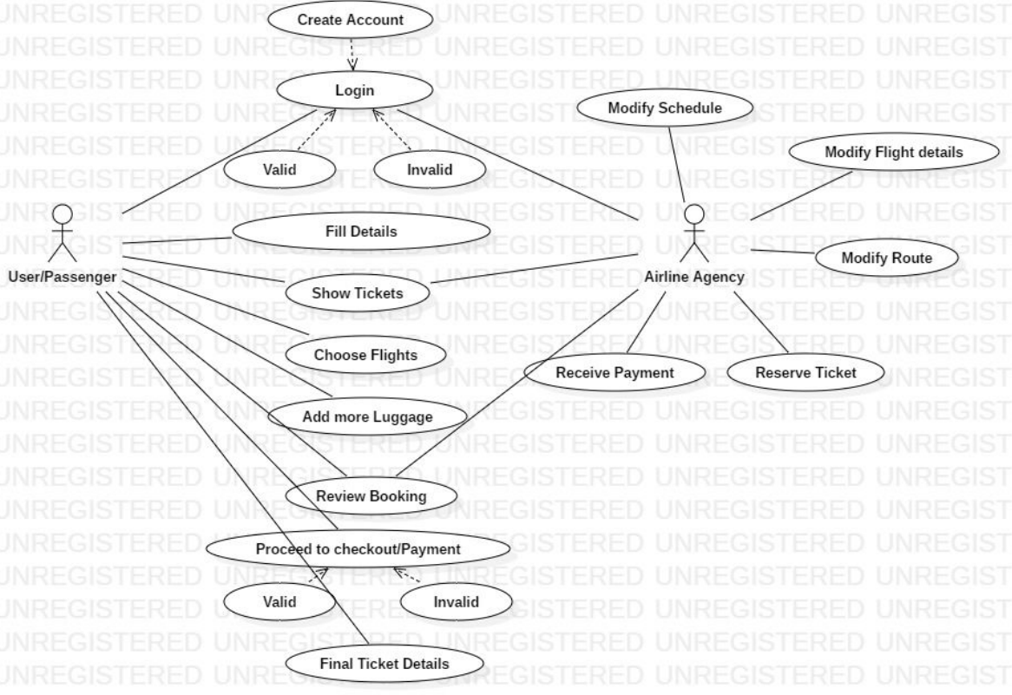

**Entity Relation Diagram:**

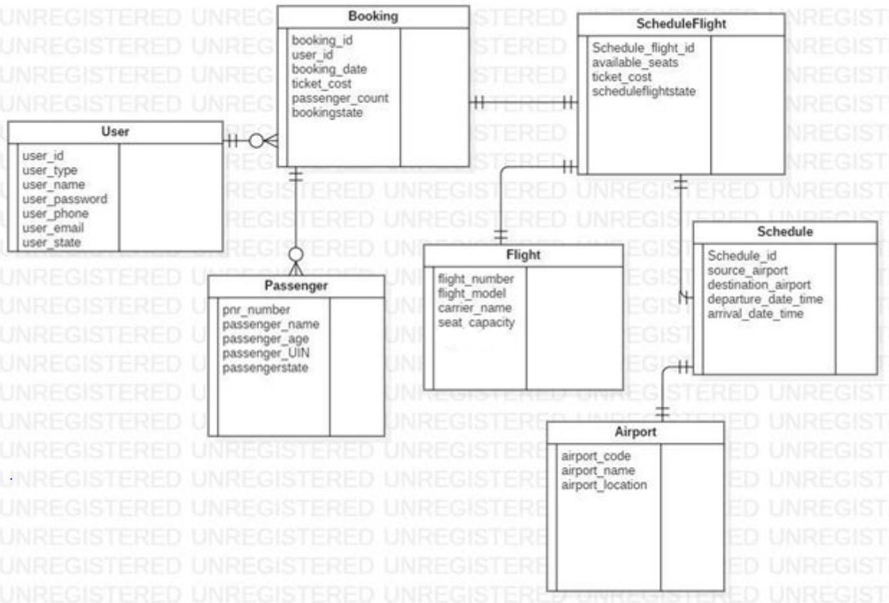

**K SUPRITHA –FLIGHT SERVICE MODULE**

**Eureka server registry:**

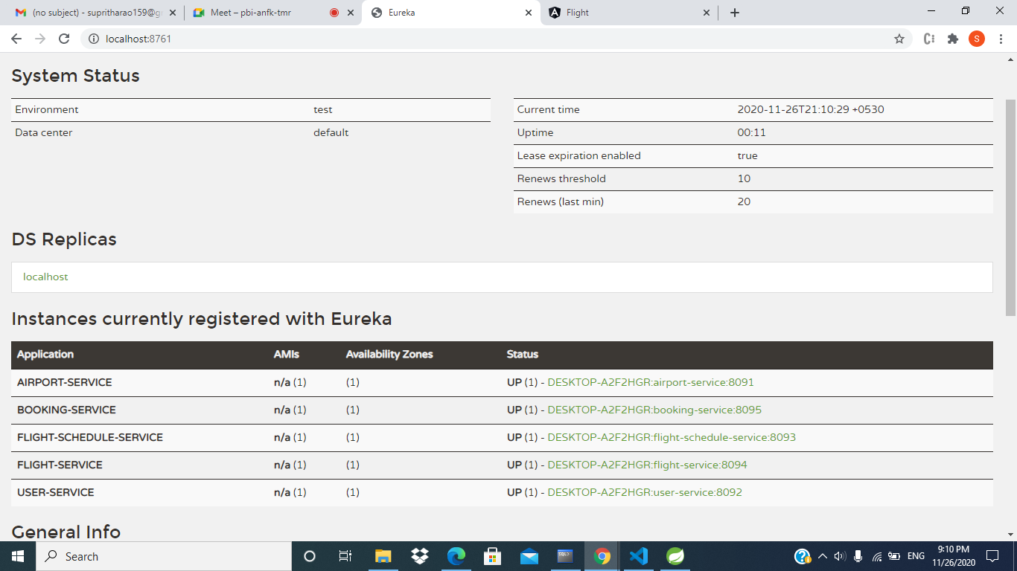

**Swagger Flight controller End points:**

